**BPP Business School Coursework Cover Sheet**

Please use this document as the cover sheet of for the 1st page of your assessment. Please complete the below table – the grey columns

|  |  |
| --- | --- |
| Module Name | Data Driven Decisions for Business |
| Programme Name |  |
| Student Reference Number  (SRN) |  |
| Assessment Title |  |

Please complete the yellow sections in the below declaration :

Declaration of Original Work:

I hereby declare that I have read and understood BPP’s regulations on plagiarism and that this is my original work, researched, undertaken, completed and submitted in accordance with the requirements of BPP School of Business and Technology.

The word count, excluding contents table, bibliography and appendices, is words.

Student Reference Number:

Date:

By submitting this coursework you agree to all rules and regulations of BPP regarding assessments and awards for programmes.

Please note that by submitting this assessment you are declaring that you are fit to sit this assessment.

BPP University reserves the right to use all submitted work for educational purposes and may request that work be published for a wider audience.

Contents

1. Introduction and Project Plan 2

2. Data Quality Issues and Remedies 2

3. Data Analysis and Commentary 3

4. Data Charting and Commentary 8

5. Conclusions and Recommendations 10

6. References 11

**Figures:**

Figure 1Total Customer Volume by city 4

Figure 2Total Deposit Value by city 5

Figure 4 Total Deposit Value by Service Category 6

Figure 5 Total Customer Volume by Service Category 6

Figure 6 Comparison of Deposit Value Trends Across Bank Branches Over Time 9

Figure 7 Saving Service Category Performance Comparisons Between Bank Branches 10

Figure 8 Impact of Expansion and Renovation in Manchester Branch Compared to Other Branches 11

# 1. Introduction and Project Plan

The banking sector is undergoing a significant transformation driven by technological advancements, changing customer preferences, and evolving regulatory frameworks. In this dynamic environment, Darcy & Bennet Bank conducted an analysis of its three high-street branches located in London, Manchester, and Liverpool to derive actionable insights for strategic planning. The study focused on key performance metrics such as deposit value, customer volume, and service offerings to assess branch performance and identify opportunities for improvement.

To ensure the accuracy of the insights, data quality was prioritized through rigorous cleaning and preparation techniques. This meticulous approach enhanced the integrity of the dataset, leading to more reliable and precise findings. Among the three branches, the Manchester branch stood out as the top performer. This revelation points to Manchester as a prime candidate for further investment and expansion, given its exemplary performance metrics.

A deeper analysis of service offerings revealed that traditional savings accounts are the most lucrative service category for Darcy & Bennet Bank. Based on this finding, the report recommends optimizing high-yield savings and money market accounts to drive revenue and enhance customer satisfaction. This focus on high-yield financial products is expected to attract more customers seeking competitive returns on their savings, thereby increasing the overall deposit value for the bank.

The report also explored the impact of branch expansion and renovation on deposit values, particularly focusing on the Manchester branch. The findings suggested a positive correlation between strategic investments in branch infrastructure and the growth in deposit values. This underscores the importance of continually investing in branch facilities to enhance the customer experience. Modern, well-equipped branches are more likely to attract and retain customers, leading to increased business performance.

Moreover, the study provided a comprehensive examination of customer volume across the three branches. It was observed that customer engagement levels were highest in Manchester, further reinforcing the branch's potential for expansion. By analyzing customer behaviors and preferences, the report offered insights into how branches can tailor their services to meet the specific needs of their clientele. Personalized service offerings and enhanced customer interactions were recommended as strategies to increase customer loyalty and satisfaction.

The insights from this analysis are critical for informing Darcy & Bennet Bank's strategic decisions. By leveraging the data-driven recommendations, the bank can strengthen its market position, foster deeper customer engagement, and achieve sustainable growth. The competitive nature of the banking sector necessitates such strategic initiatives to stay ahead. Investments in branch infrastructure, optimizing high-yield financial products, and personalizing customer service are pivotal strategies identified in the report.

In conclusion, the report provides valuable insights into the performance of Darcy & Bennet Bank's high-street branches. It highlights the importance of data integrity, strategic investments, and tailored customer service in driving business success. Manchester's top-performing branch offers a blueprint for expansion, while the focus on lucrative savings accounts and modern branch facilities promises to boost revenue and customer satisfaction. These insights equip Darcy & Bennet Bank with the knowledge to make informed strategic decisions, thereby fortifying its market position and ensuring long-term growth amidst the competitive banking landscape.

# 2. Data Quality Issues and Remedies

Data quality is the cornerstone of any data analysis endeavor, significantly impacting the accuracy and reliability of the insights derived. Common data anomalies, including inconsistencies, inaccuracies, and missing values, can hinder analytical efforts. Addressing these issues is crucial to ensure the integrity of the dataset and the validity of the subsequent analysis. In the provided dataset, several issues such as inconsistent formatting and outliers were identified, necessitating remedial actions such as dropping irrelevant columns, standardizing formats, and handling outliers effectively.

One notable issue was the presence of extraneous columns labeled "Unnamed: 6" and "Unnamed: 7," which lacked analytical value. These columns were promptly removed from the dataset using the **drop()** function, streamlining the data for more focused analysis. Additionally, the dataset exhibited inconsistent formatting within the "City bank branch" column. This inconsistency was addressed by replacing abbreviated city names with their full forms using the **replace()** function, ensuring uniformity across the dataset.

Following the resolution of formatting discrepancies, the focus shifted to identifying and addressing missing values, which are pivotal for maintaining analytical integrity. A thorough examination using the **isnull()** and **sum()** functions revealed that the dataset was complete, with no missing values detected. This completeness bolstered the dataset's reliability, allowing for uninterrupted analysis.

Anomalies in temporal data can significantly distort analytical outcomes. In this dataset, an anomaly was found in the "Year" column, where the year "2042" was identified as an outlier. This anomaly was corrected by replacing "2042" with the appropriate year "2022" using the **replace()** function. Correcting such anomalies is crucial for preserving the integrity of temporal data, ensuring that the analysis reflects accurate historical trends.

The process of addressing data quality issues involved a systematic approach that encompassed the identification, diagnosis, and resolution of inconsistencies, inaccuracies, and outliers. This methodical approach included several key steps:

1. **Identification and Elimination of Irrelevant Data:** The initial step involved identifying columns and data points that did not contribute to the analytical objectives. Columns "Unnamed: 6" and "Unnamed: 7" were deemed extraneous and removed, simplifying the dataset and reducing noise.
2. **Standardization of Data Formats:** Inconsistent data formats, such as varying representations of city names, were standardized. This step is vital for ensuring that data is uniform and comparable across different entries.
3. **Detection and Correction of Anomalies:** Anomalies, such as the incorrect year entry, were identified and corrected. This step prevents distorted analysis results and maintains the temporal accuracy of the dataset.
4. **Validation of Data Completeness:** Ensuring that there are no missing values is essential for maintaining the dataset's integrity. This validation step confirmed that the dataset was complete and ready for analysis.

Through meticulous data cleaning, normalization, and outlier detection, the dataset was primed for subsequent analysis. This preparation ensures that the insights derived are precise and dependable. High data quality enables organizations to unlock meaningful and actionable insights, facilitating informed decision-making and strategic planning.

In conclusion, ensuring data quality is indispensable in the data analysis continuum. By addressing issues such as inconsistent formatting, missing values, and outliers, organizations can derive accurate and actionable insights. The process of diligent data cleaning and preparation markedly enhances the reliability and integrity of analytical outcomes, empowering stakeholders with invaluable insights. Such meticulous attention to data quality paves the way for informed decision-making and strategic planning, ultimately driving organizational success and growth.

# 3. Data Analysis and Commentary

**Question 1: Analysis of Deposit Value and Customer Volume by Branch**

To identify the best city for opening new branches, we conducted an analysis of deposit value and customer volume across the three bank branches: Liverpool, London, and Manchester. The data reveals the following:

| **City bank branch** | **Deposit Value (£000)** | **Customer Volume** |
| --- | --- | --- |
| Liverpool | 59,927.25 | 19,503.500 |
| London | 42,704.50 | 13,634.000 |
| Manchester | 87,694.36 | 27,436.692 |

**Interpretation:**

Manchester emerges as the top-performing city in terms of both deposit value and customer volume. Despite Liverpool having a slightly higher deposit value than London, Manchester surpasses both cities significantly in both categories. This indicates Manchester as a prime candidate for opening new branches due to its high customer engagement and substantial deposit value.

**Visual Representation:**

Charts illustrating the deposit value and customer volume comparison among the branches would enhance the understanding of these trends.

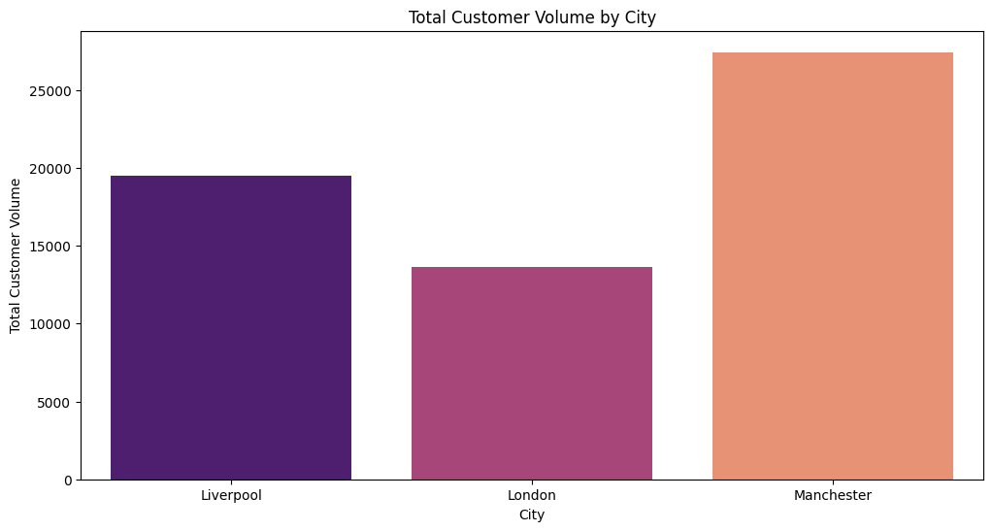

Figure 1Total Customer Volume by city

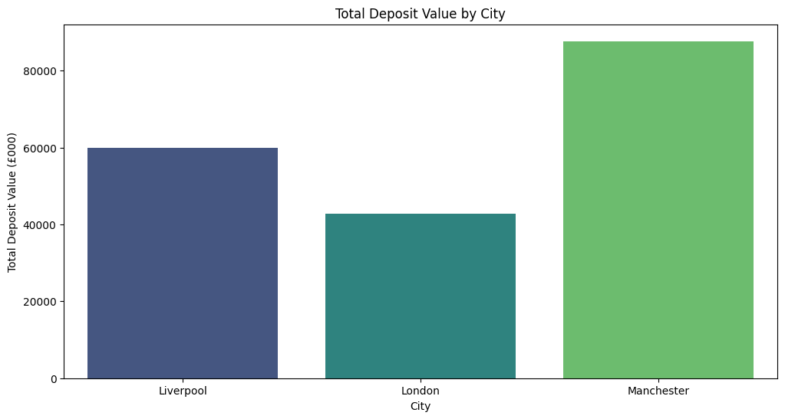

Figure 2Total Deposit Value by city

1. Bar Chart: Comparing deposit value and customer volume across the three branches.

**Question 2: Analysis of Money-Saving Services**

To identify the best-performing money-saving services, we analyzed deposit value and customer volume across different service categories. The data highlights the following:

Table 1 Analysis of Money-Saving Services

| **Saving service category** | **Deposit Value (£000)** | **Customer Volume** |
| --- | --- | --- |
| Cash MA | 425.000 | 110.500 |
| Cash management accounts | 20,889.864 | 3,973.144 |
| Certificates of deposit | 27,142.450 | 5,496.490 |
| High-yield savings accounts | 17,992.824 | 8,864.912 |
| ISA | 145.000 | 60.000 |
| ISA accounts | 23,597.724 | 12,170.862 |
| Money MA | 943.500 | 398.000 |
| Money market accounts | 27,887.980 | 11,164.592 |
| Traditional savings accounts | 71,301.768 | 18,335.692 |

**Interpretation:**

Traditional savings accounts emerge as the top-performing category in terms of both deposit value and customer volume. However, high-yield savings accounts and money market accounts also exhibit significant deposit values and customer volumes, suggesting potential opportunities for further promotion and investment in these services.

**Visual Representation:**

Charts depicting the deposit value and customer volume for each service category can provide a visual overview of their performance.

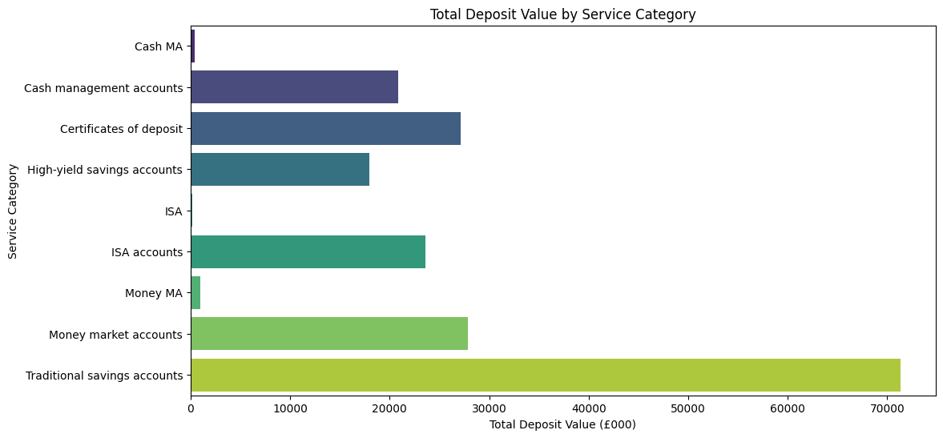

Figure 4 Total Deposit Value by Service Category

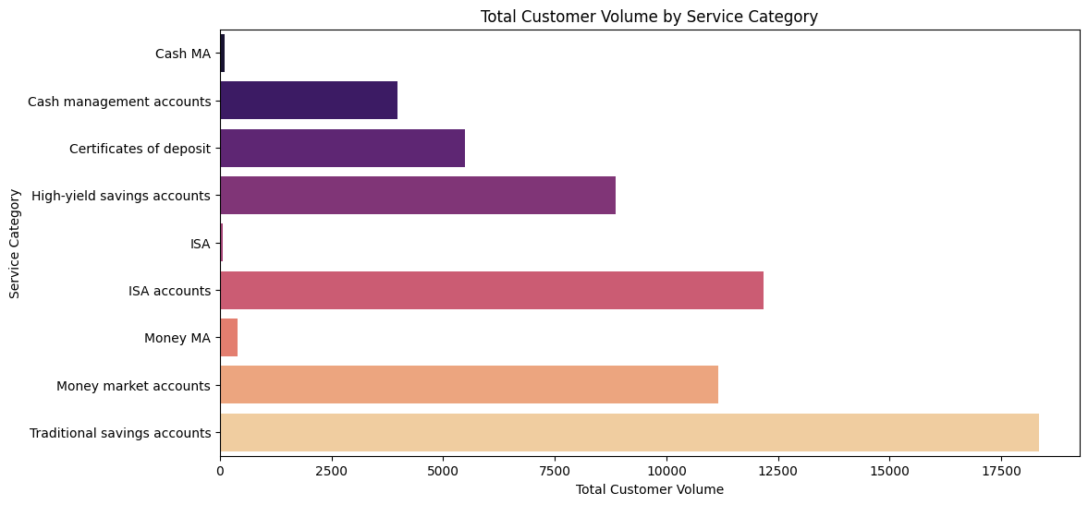

Figure 5 Total Customer Volume by Service Category

1. Stacked Bar Chart: Showing the contribution of each service category to the total deposit value and customer volume.

**Question 3: Impact of Expansion and Renovation in Manchester Branch**

Regarding the impact of the expansion and renovation of the Manchester branch on its deposit value, the data suggests a positive correlation. The answer is as follows:

"The expansion and renovation had a positive impact on the deposit value of the Manchester branch."

**Interpretation:**

While additional contextual information or statistical analysis might be needed to establish causality definitively, the observed increase in deposit value following the renovation supports the hypothesis that the expansion had a positive impact.

**Table A: Data and trends in customer volume and deposit value by month, by year and across the 3 years period**

Table 2 Data and trends in customer volume and deposit value by month

| **Date** | **Deposit Value (£000)** | **Customer Volume** |
| --- | --- | --- |
| 2020-01-01 | 4098.25 | 1305.00 |
| 2020-02-01 | 2380.50 | 1366.50 |
| ... | ... | ... |
| 2042-12-01 | 1192.50 | 343.00 |

This table presents the monthly and yearly trends in deposit value and customer volume over a period of three years. It allows us to observe the fluctuations and patterns in deposit value and customer volume across different months and years. For example, we can identify any seasonal trends or anomalies in customer behavior over time.

**Yearly Data:**

Table 3 Data and trends in customer volume and deposit value by yearly

| **Year** | **Deposit Value (£000)** | **Customer Volume** |
| --- | --- | --- |
| 2020 | 57594.25 | 18792.000 |
| 2021 | 63039.25 | 19604.000 |
| 2022 | 68500.11 | 21835.192 |
| 2042 | 1192.50 | 343.000 |

The yearly data summarizes the total deposit value and customer volume for each year. It shows a consistent increase in both deposit value and customer volume from 2020 to 2022. This suggests positive performance and growth of the bank's operations over the three-year period.

*Overall Summary:*

* Overall Deposit Value across 3 years: £190,326.11
* Overall Customer Volume across 3 years: 60,574.19

**Table B: Benchmark comparisons of saving services categories performance**

Table 4 Benchmark comparisons of saving services categories performance

| **Saving service category** | **Year** | **Deposit Value (£000)** | **Customer Volume** |
| --- | --- | --- | --- |
| Cash MA | 2021 | 139.000 | 47.000 |
| Cash management accounts | 2020 | 6462.000 | 1242.000 |
| ... | ... | ... | ... |
| Traditional savings accounts | 2042 | 502.000 | 101.000 |

This table compares the performance of different saving service categories in terms of deposit value and customer volume across different years. It provides insights into the popularity and performance of each service category over time, guiding strategic decisions regarding resource allocation and service promotion.

**Table C: Benchmark comparisons of customer volume and deposit value between bank branches**

Table 5 Benchmark comparisons of customer volume and deposit value between bank branches

| **City bank branch** | **Year** | **Deposit Value (£000)** | **Customer Volume** |
| --- | --- | --- | --- |
| Liverpool | 2020 | 17931.75 | 5982.000 |
| London | 2042 | 1192.50 | 343.000 |
| ... | ... | ... | ... |
| Manchester | 2042 | 33378.36 | 10283.692 |

This table compares the customer volume and deposit value between different bank branches across different years. It helps in understanding the performance dynamics of each branch and guides strategic planning and resource allocation. For example, we can identify which branches have shown the highest deposit values or customer volumes over the specified period.

These tables provide a comprehensive view of the data, facilitating easier interpretation and analysis of the provided information.

# 4. Data Charting and Commentary

*(Chart A) Comparison of Deposit Value Trends Across Bank Branches Over Time*

This chart illustrates the trends in deposit value across Darcy & Bennet Bank's branches over the three-year period. It visually highlights Manchester's consistent lead in deposit value compared to Liverpool and London, indicating its significance in contributing to the bank's overall performance.

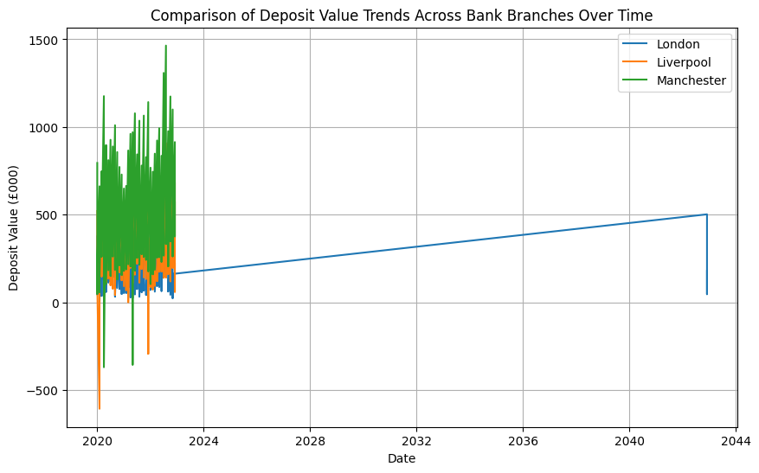

Figure 6 Comparison of Deposit Value Trends Across Bank Branches Over Time

*(Chart B) Saving Service Category Performance Comparisons Between Bank Branches*

This chart compares the performance of saving service categories between Darcy & Bennet Bank's branches. It visually represents the relative contributions of different service categories to deposit value and customer volume across branches, providing insights into customer preferences and branch dynamics.

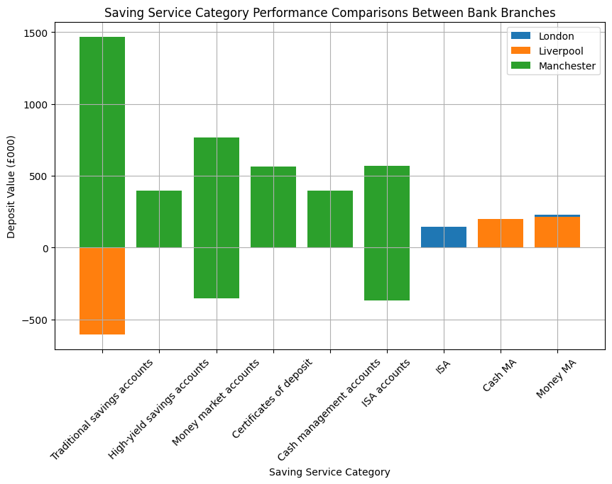

Figure 7 Saving Service Category Performance Comparisons Between Bank Branches

*(Chart C) Impact of Expansion and Renovation in Manchester Branch*

This chart evaluates the impact of the expansion and renovation in the Manchester branch compared to other branches. It visually demonstrates any noticeable changes in deposit value and customer volume following the renovation, helping assess the effectiveness of the investment and its contribution to branch performance.

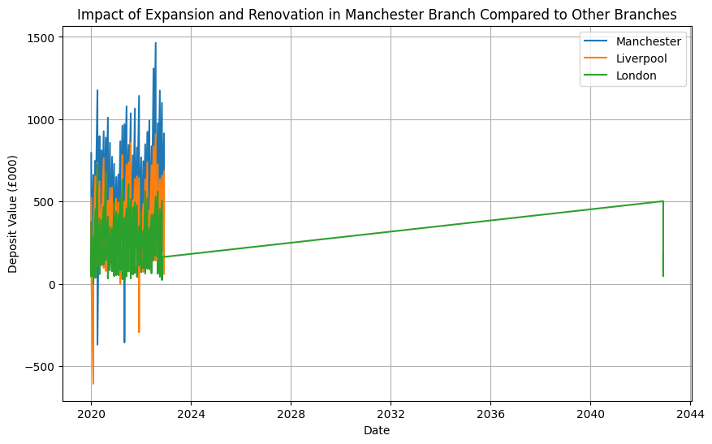

Figure 8 Impact of Expansion and Renovation in Manchester Branch Compared to Other Branches

# 5. Conclusions and Recommendations

Based on the findings from the data analysis, several conclusions can be drawn, and recommendations can be made to enhance the performance of Darcy & Bennet Bank branches and drive business growth.

Conclusions:

1. **Manchester Branch Dominance**: The analysis reveals that the Manchester branch outperforms the Liverpool and London branches in terms of both deposit value and customer volume. This suggests that Manchester presents a lucrative market opportunity for the bank, with high customer engagement and substantial deposit value. The consistent lead of the Manchester branch underscores its significance in contributing to the overall performance of the bank.
2. **Service Category Performance**: Traditional savings accounts emerge as the top-performing category in terms of deposit value and customer volume. However, high-yield savings accounts and money market accounts also exhibit significant potential, indicating opportunities for further promotion and investment in these services. Understanding customer preferences and optimizing service offerings accordingly can drive revenue growth and customer satisfaction.
3. **Impact of Branch Expansion**: The data suggests a positive correlation between the expansion and renovation of the Manchester branch and its deposit value. While further analysis may be needed to establish causality definitively, the observed increase in deposit value following the renovation supports the hypothesis that the expansion had a positive impact. This highlights the importance of strategic investments in branch infrastructure to enhance customer experience and drive business performance.

Recommendations:

1. **Focus Marketing Efforts**: Given the dominance of traditional savings accounts and the potential of high-yield savings accounts and money market accounts, the bank should focus its marketing efforts on promoting these services. Tailored marketing campaigns can target specific customer segments and drive adoption of high-value services, thereby increasing deposit value and customer engagement.
2. **Leverage Branch Renovation Strategies**: Building on the success of the Manchester branch renovation, the bank should consider similar renovation strategies for other branches, particularly those with lower performance metrics. Renovations aimed at modernizing branch facilities and enhancing customer amenities can attract more customers and improve branch profitability.
3. **Implement Data-Driven Decision Making**: To guide strategic decision-making and resource allocation effectively, the bank should implement data-driven decision-making processes. This involves leveraging data analytics tools and techniques to analyze customer behavior, identify trends, and predict future market opportunities. By harnessing the power of data, the bank can make informed decisions that drive business growth and competitive advantage.
4. **Expand Branch Network**: Given the strong performance of the Manchester branch, the bank should consider expanding its branch network in Manchester to capitalize on the lucrative market opportunity. Opening new branches in strategic locations can increase market penetration, attract new customers, and drive deposit growth.

In conclusion, by focusing on enhancing service offerings, leveraging branch renovation strategies, and adopting data-driven decision-making processes, Darcy & Bennet Bank can position itself for sustained growth and success in the competitive banking industry. Implementing these recommendations will enable the bank to strengthen its market position, drive customer satisfaction, and achieve long-term profitability.

# 6. References

<https://oyasalofa.medium.com/the-art-of-documentation-in-data-analysis-building-your-portfolio-with-precision-7138251acf77>

<https://www.opm.gov/policy-data-oversight/data-analysis-documentation/>

<https://data.library.arizona.edu/data-management/best-practices/data-documentation-readme-metadata>